Git & GitHub challenges
- Resolve Merge Conflicts
  - Create a merge conflict intentionally (two users editing the same line).
  - Resolve the conflict and push the changes.

- Created a new directory, Git_3 in local machine
- Created a example.txt file & done the add, commit
- Created a new branch, feature
- Again in master branch created a demo.txt & demo.txt in feature branch
- And done with add, commit changes
- git merge Feature to master branch a merge conflict is raised & edited the file demo.txt as per my requirement & then add & commit
- Now Pushed the source code of master and feature branches to the central repo, Test-02.
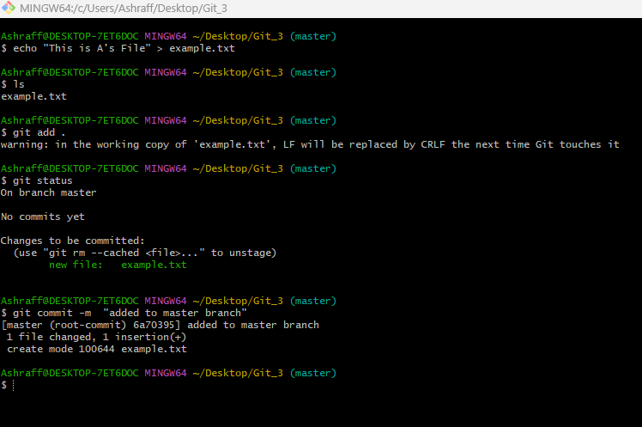

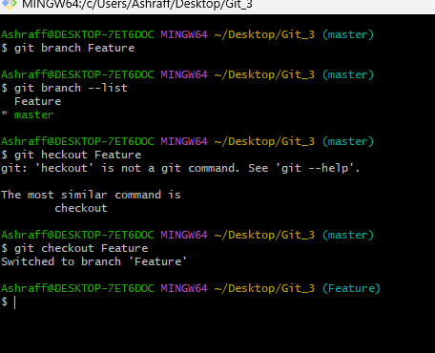

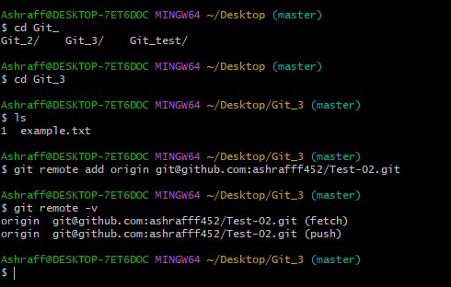

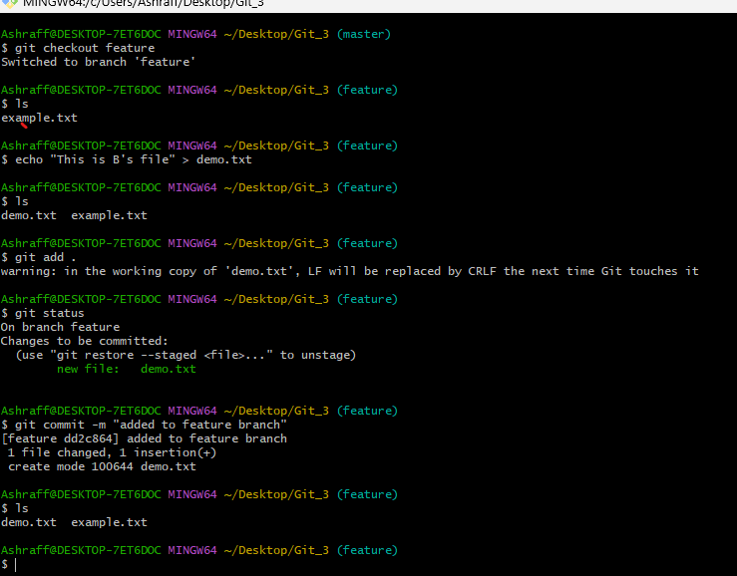

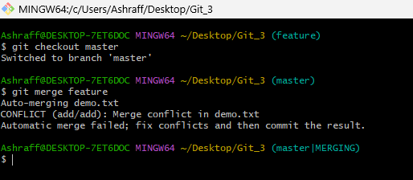

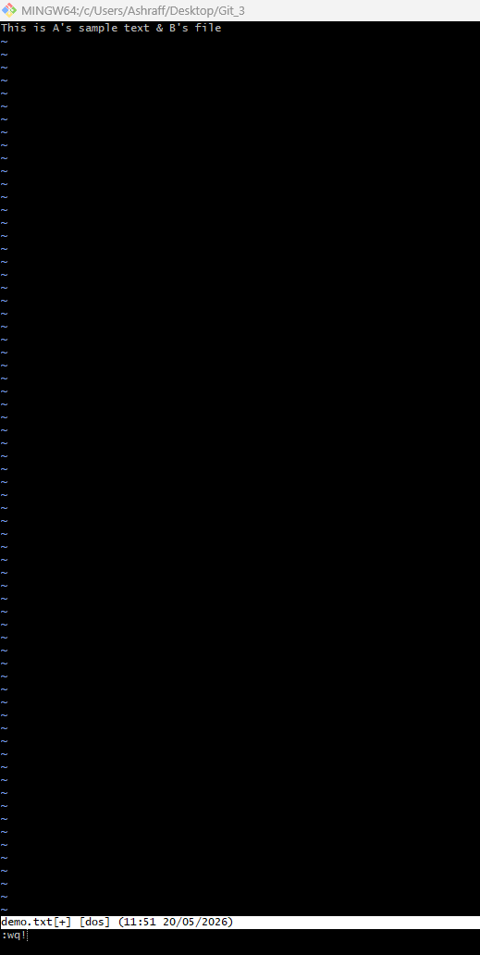
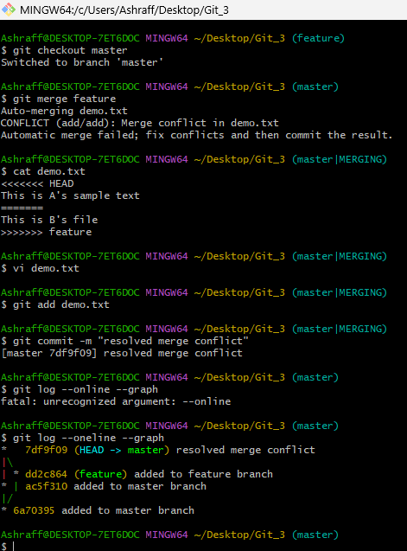

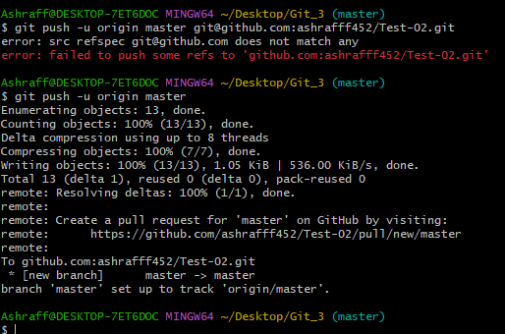

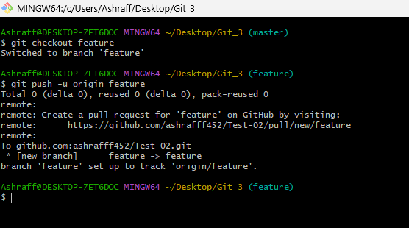

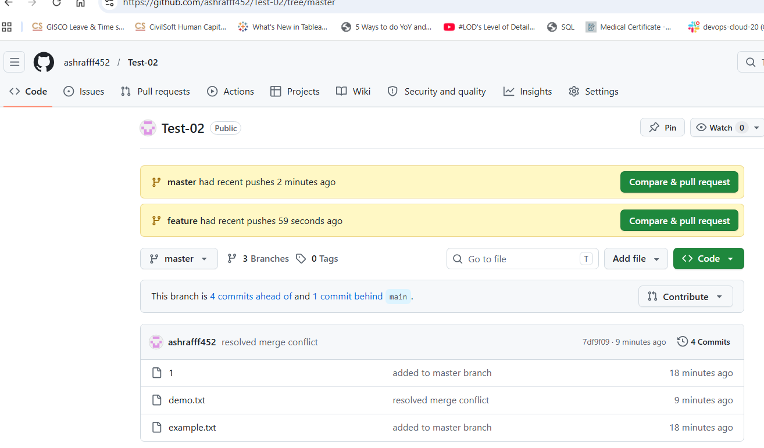

- Recover Deleted Branch
  - Delete a local branch and then recover it using the reflog.

- Created a new branch branch1 by the command git branch branch1 from master branch
- All the file of master branch are present in branch1
- Deleted the branch1 by using command git branch -d branch1
- Checked the available branches by the command, git branch –list
- To recover the deleted branch first used the command git reflog to know the commit hash of the deleted branch.
- Then used command git branch branch1 7df9f09 to recover the deleted branch & checked the branch1 recovery by git branch –list command
- Later pushed the branch by the command, git push -u origin branch1
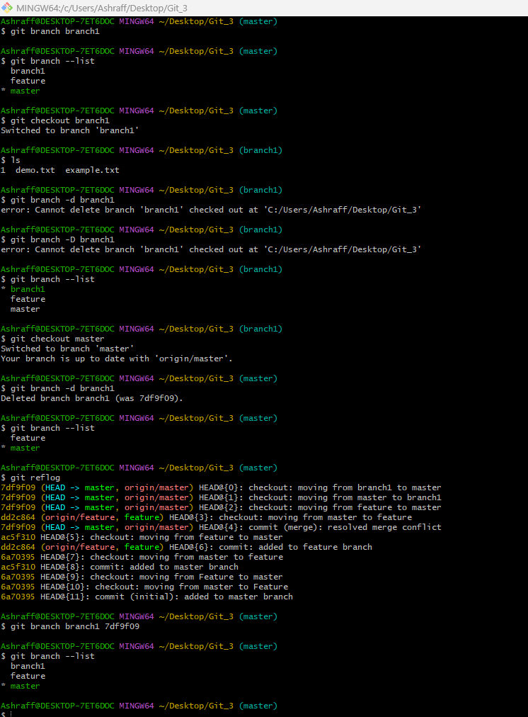
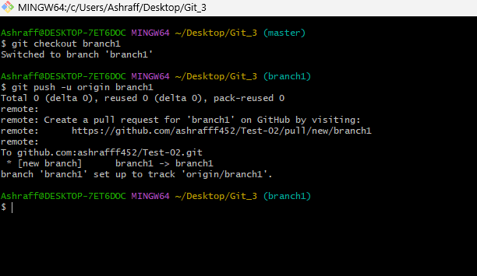

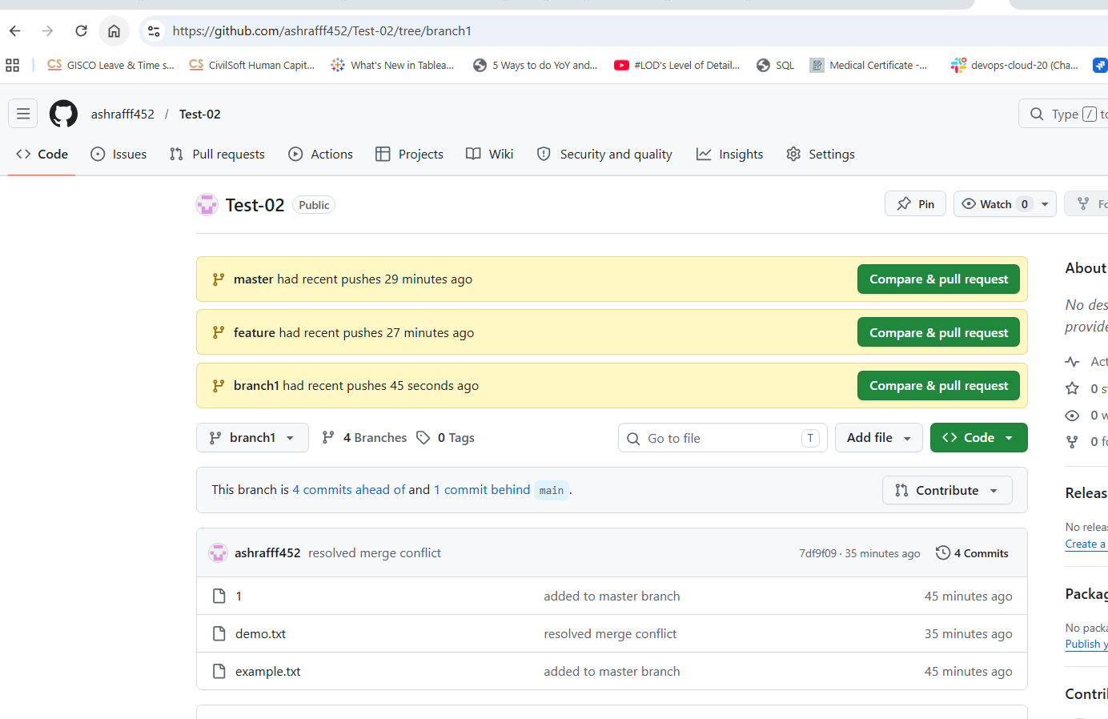

- Undo Wrong Push
  - Push a wrong commit to GitHub, then undo it without losing history.

- Created a file F1.txt in master branch
- Done the add, commit & pushed to the central repo
- By using git log –oneline command & git revert 3892da6 deleted the File F1.txt
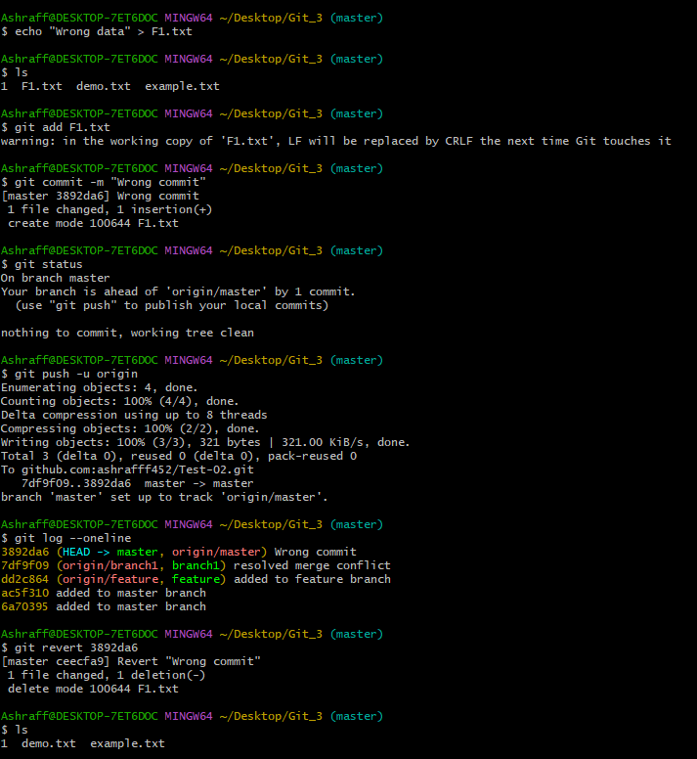

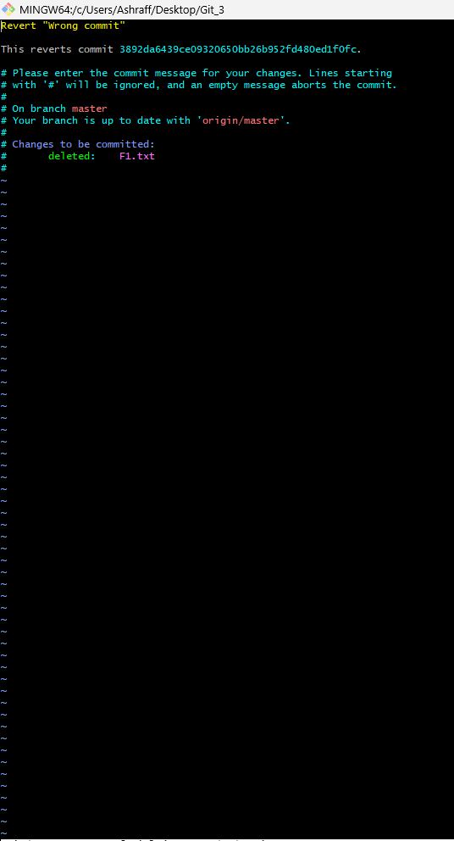

- Amend a Commit
  - Make a commit, then add a missing file to it usinggit commit --amend.

- By using command, git log –oneline the list is visible for which the last commit message is “wrong commit” & changed the commit message as “Changed the commit message using amend command to the commit id, ceecfa9”
- Used command, git commit –amend & done the changes and save.
- By command git log –oneline the change of commit message is reflecting.
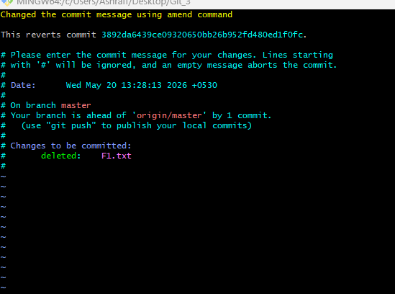

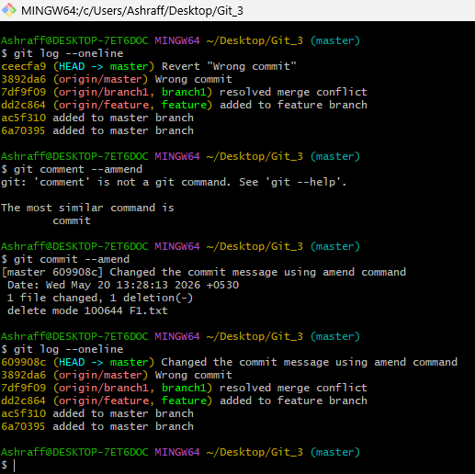

- Cherry-pick a Commit
  - Take a specific commit from one branch and apply it to another branch.

- Created a.txt & b.txt files in branch1 and done the add and commit.
- Copied the commit id of commit of a.txt & b.txt files, 180f1fa by using, git log –oneline command
- By using command, git checkout master to master branch.
- By the command git cherry-pick 180f1fa the commit is copied to master branch with files a.txt & b.txt .
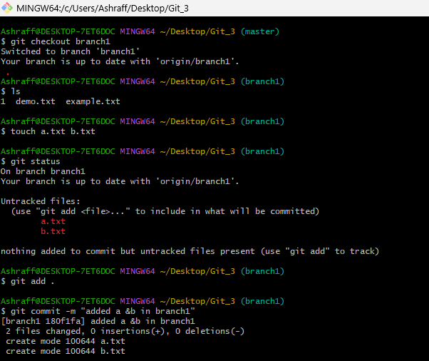

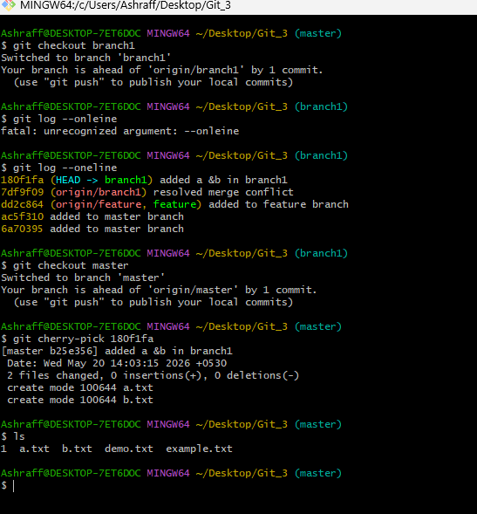

- Interactive Rebase
  - Reorder and squash multiple commits into a single clean commit.

- git log –oneline command to see the commits
- Use command, git rebase -I HEAD~2 to club the three commits into a single commit.
- Change to squash for the 2nd commit keeping pick as 1st commit save and enter
- Now git log –oneline command shows the list that the 2 commits into a single commit showing the rest commits as well.

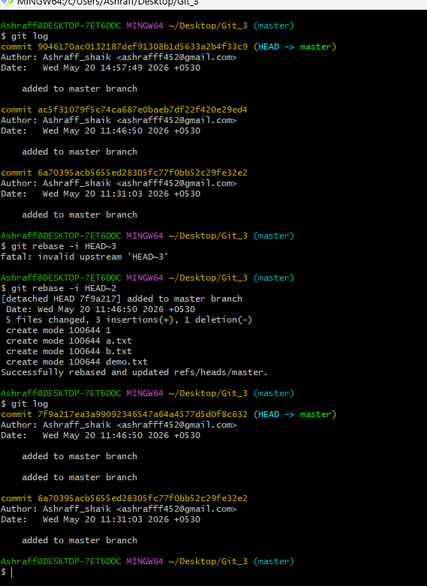

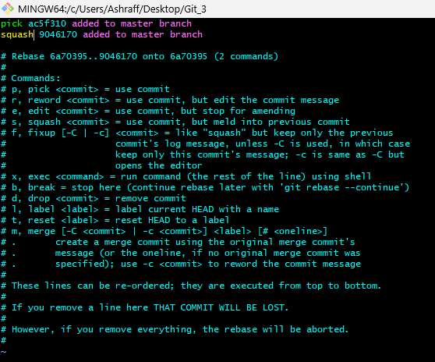

- Tagging & Release
  - Create a version tag (v1.0), push it to GitHub, then delete and restore it.

- Created a tag V1.0 by the command, git tag -a v1.0 -m “version 1.0 release”
- Later check it by git tag command. Now push to central repo, GitHub by the command, git push origin v1.0 .
- git tag -d v1.0 to delete from local machine
- git push origin –delete v1.0 from GitHub
- git log –oneline copy the commit Id
- git tag -a v1.0 7f9a217 -m “Restored v1.0 tag” to restore to local machine
- git push origin v1.0 to push and restore to GitHub

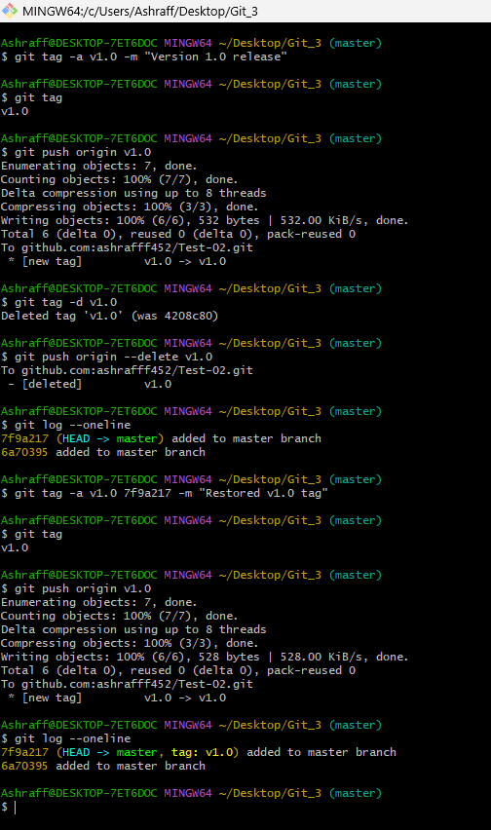
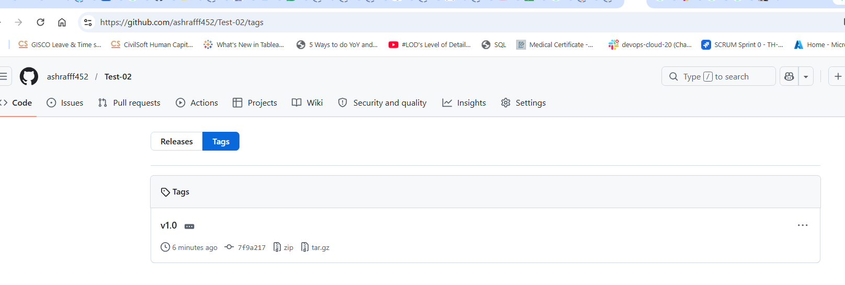
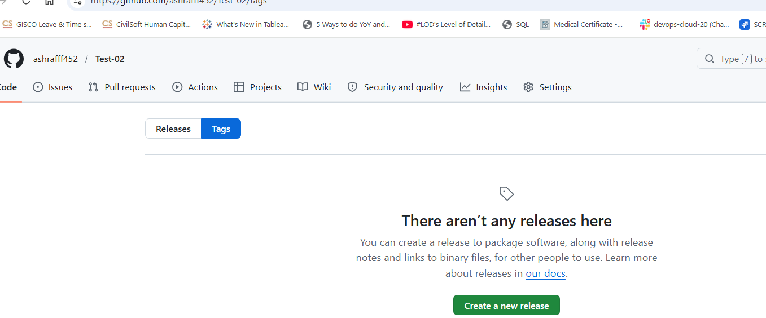



- Clone with Sparse Checkout
  - Clone only a subdirectory of a repo using sparse checkout.

- Create a repo in gitHub and clone it to our local machine by using the command, git clone –no-checkout https://github.com/ashrafff452/Test-02.git
- Cd Test-02 & git sparse-checkout init –cone
- Then specify the file/sub-directory to pull from repo git sparse-checkout set example.txt
- To verify we use the command, git sparse-checkout list.
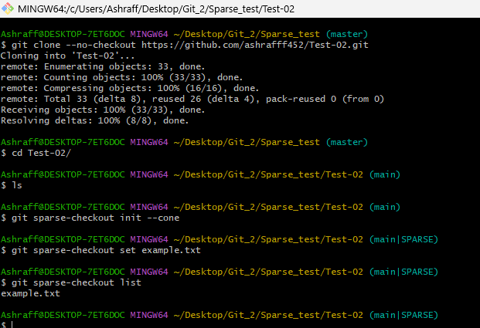

- Reset vs Revert Challenge
  - Demonstrate the difference betweengit reset --hardandgit revertin repo.
Both commands undo changes in Git, but they work very differently.
Command | Effect
git reset –hard | Removes commits and rewrites history
git revert | Creates a new commit that undoes changes

- Created a file app.txt in branch1 and appended Version1, Version2 & Version3 as three commits and now
- git reset –hard HEAD~1 removes the last commit
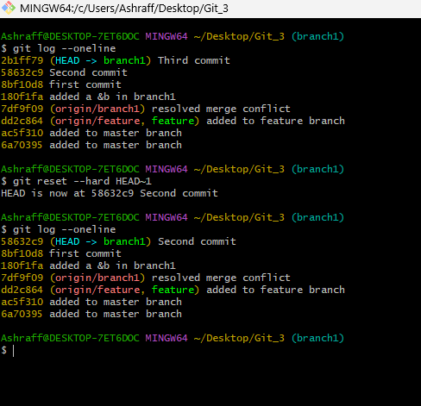
  - Now again appended to app.txt file as Vesrion3 with a new commit
  - From command, git log –oneline we copy the commit Id of last commit and revert with git revert HEAD creates a new commit by deleting the Version3 append in last commit.
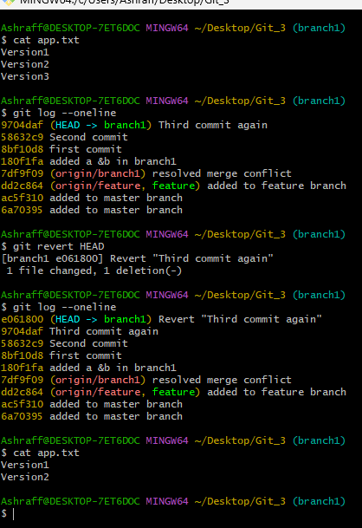

- Detached HEAD Challenge
  - Checkout a specific commit (detached HEAD state) and create a new branch from it.

  - From branch1 used the command, git log –online, for commit Id
  - git checkout 58632c9 made us to move to detached HEAD state
  - echo “Testing detached HEAD ” > test.txt to create a file & later add & commit
  - git checkout -b recovery_branch1 to create a new branch, recovery_branch1
  - git branch –list to see the newly created branch.
  - git push origin recovery_branch1 to GitHub repository
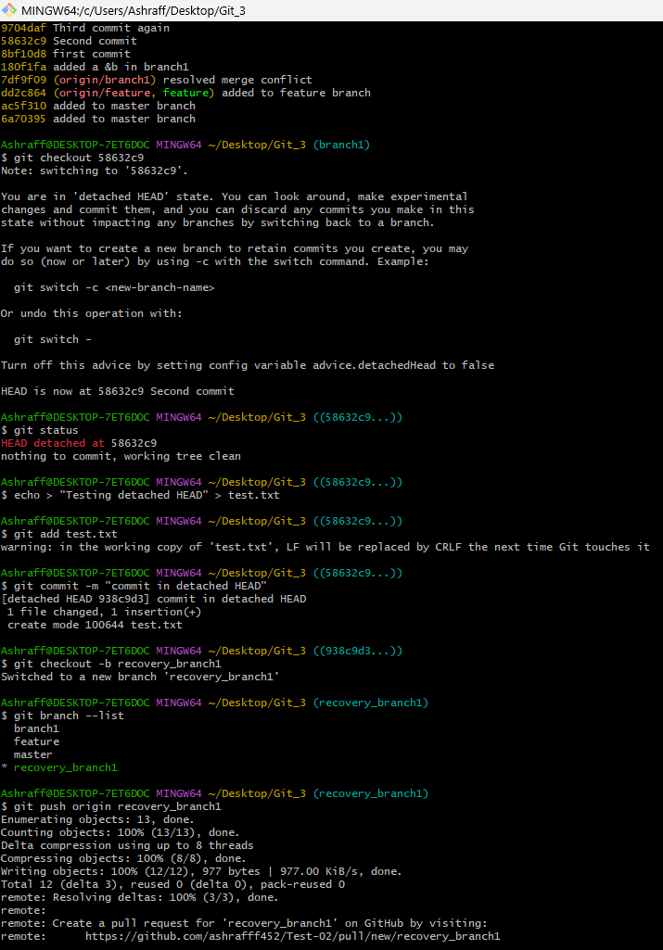
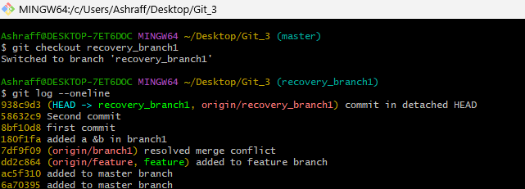

- Git Hooks Challenge
  - Configure apre-commithook to reject commits without a message format (e.g., must start withJIRA-XXX).

- We need to Make Hook Executable: cd .git/hooks & vi commit-msg
- Create commit-msg Hook with below script:

#!/bin/bash
commit_msg_file=$1
commit_msg=$(cat "$commit_msg_file")
pattern="^JIRA-[0-9]+"
if [[ ! $commit_msg =~ $pattern ]]
then
echo "ERROR: Commit message must start with JIRA-XXX"
echo "Example: JIRA-101 Fixed login bug"
exit 1
fi

  - Make Hook Executable: chmod +x commit-msg
  - Go Back to Repository, Git_3 of master branch
  - Created a sample file, touch test_hook.txt
  - Add content: echo "Testing hooks" > test.txt
  - git add test.txt & git commit -m "Added test file"
  - ERROR: Commit message must start with JIRA-XXX
  - Test Valid Commit: git commit -m "JIRA-101 added test file"
  - Verify Commit: git log --oneline

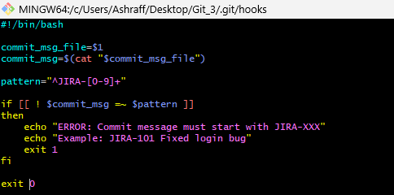
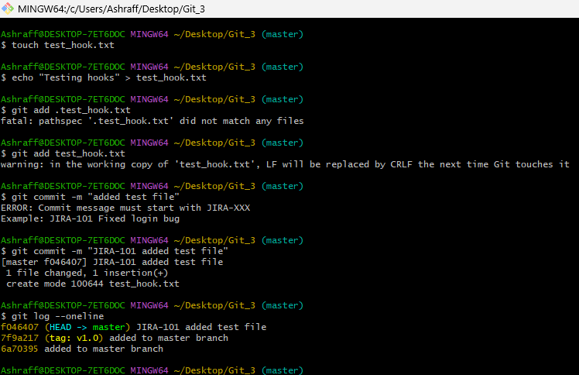

- Squash Merge vs Rebase Merge
  - Show the difference between squash merge and rebase merge with evidence.

Squash Merge:
- Create Repository: mkdir git-demo & cd git_demo
- Create Initial Commit:git_init
- Create Initial Commit: echo "Initial Code" > app.txt & then add & commit
- Create Feature Branch: git branch feature & git checkout feature
- Create 3 Commits in Feature Branch
- Check Feature Branch History: git log –oneline
- Switch to Master: git checkout master
- Perform Squash Merge: git merge --squash feature
- Output: Squash commit -- not updating HEAD
- Check Git History :git log –oneline
- 3 commits become ONE commit.

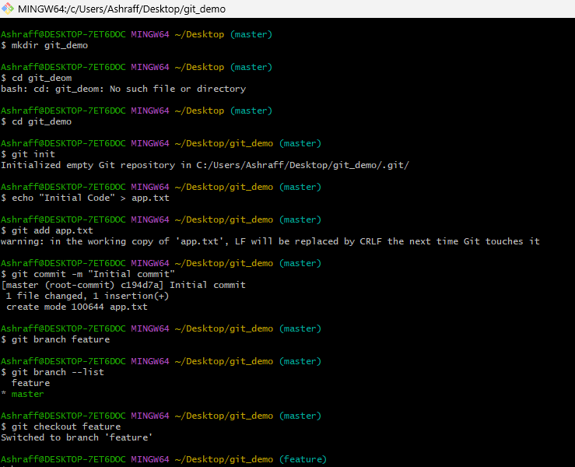

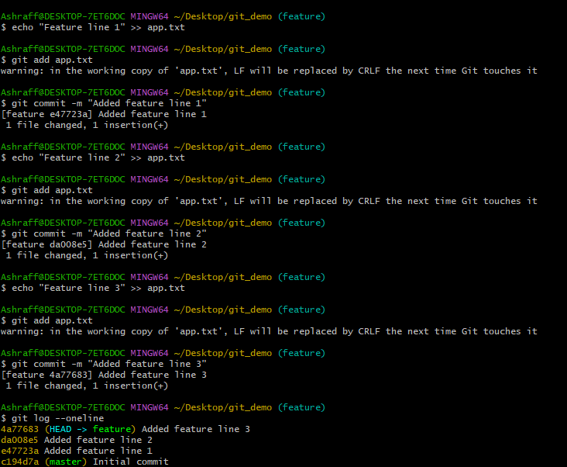

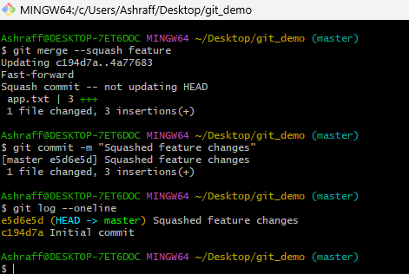

Rebase Merge:
  - Create New Feature Branch:git branch feature-rebase
  - Create two Commits
  - Check History: git log –oneline
  - Switch to Master: git checkout master
  - Rebase Feature Branch: git checkout master
          - git merge feature-rebase
  - Check Final History: git log –oneline
  - Unlike squash merge: remain visible individually
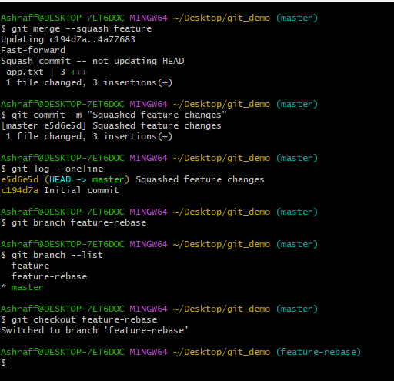

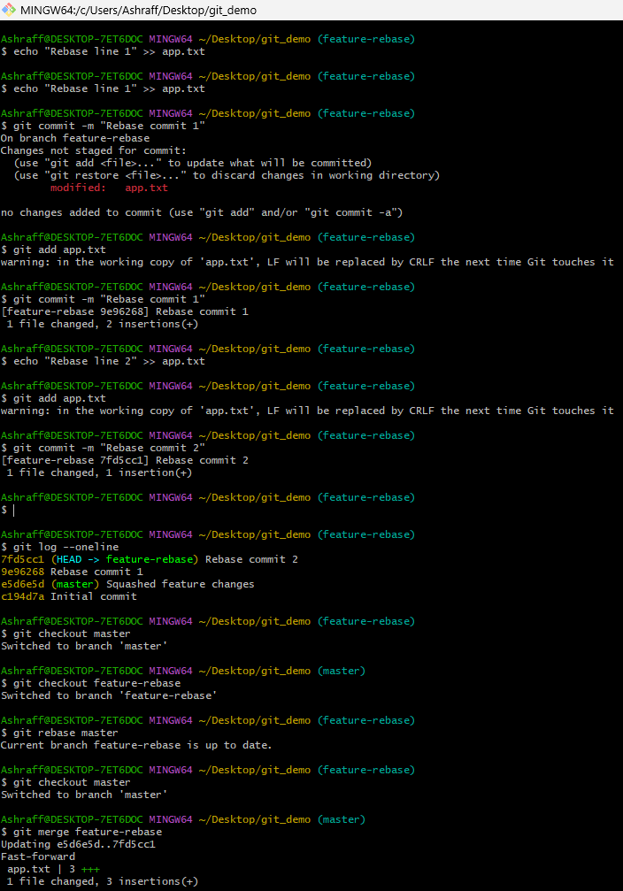
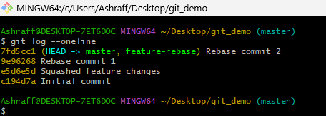
- Fork & Pull Request Workflow
  - Fork a repo, make a change, and submit a pull request to the original repo.

  - Create a fork on another’s account.
  - Click on, https://github.com/krishnasanthosh6160/git-github.git
  - Create a fork with same/new name to a new directory, santosh_rep
  - Then get init & configure git remote -v & then clone by command
  - Go to repo, git_githubgit & clone git@github.com:krishnasanthosh6160/git-github.git
  - Create New Branch, git branch feature-update
  - Checkout by git checkout feature-update
  - Create a AA file, add & do the commit & push to the central repo by,
  - git push origin feature-update
  - Open GitHub Fork Compare & pull request & successfully merged with AA file.
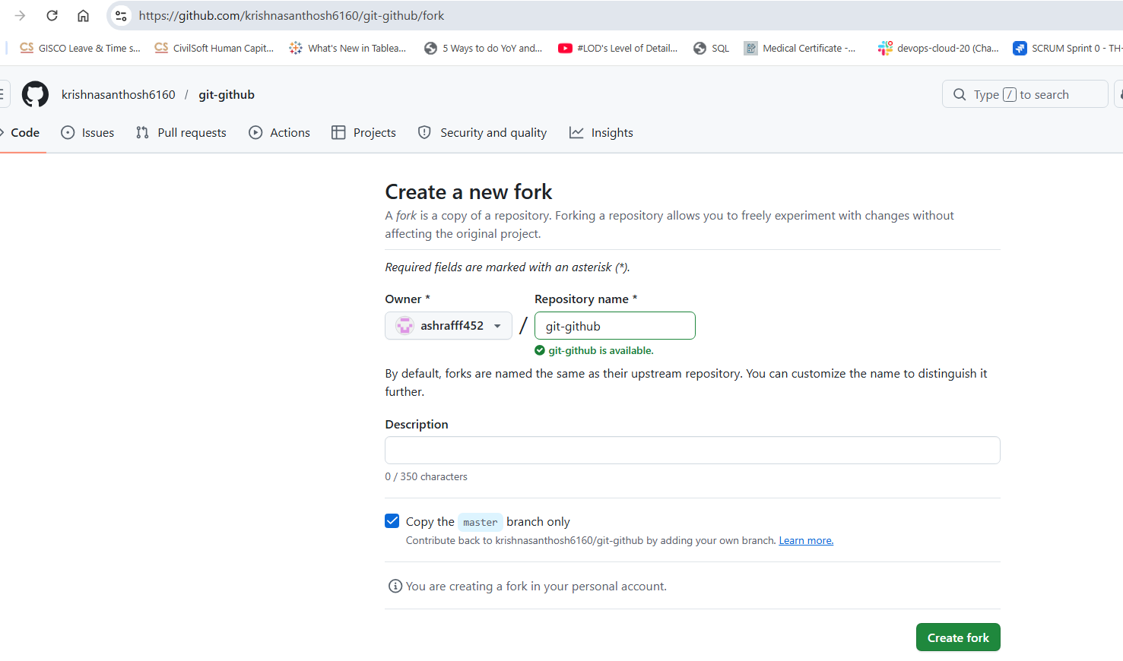
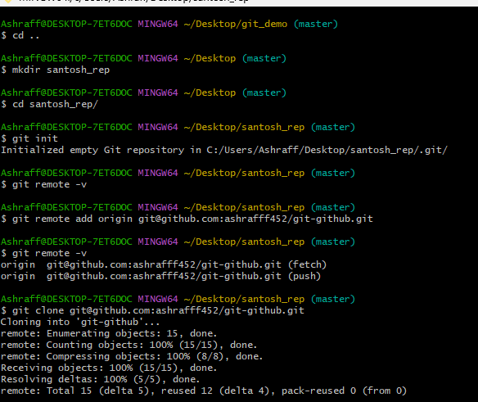
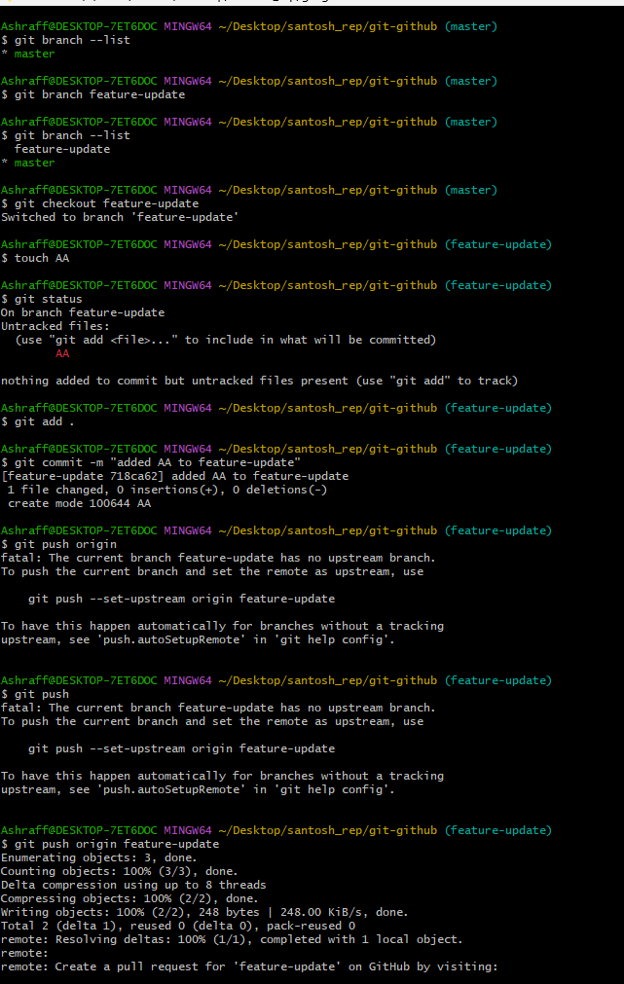
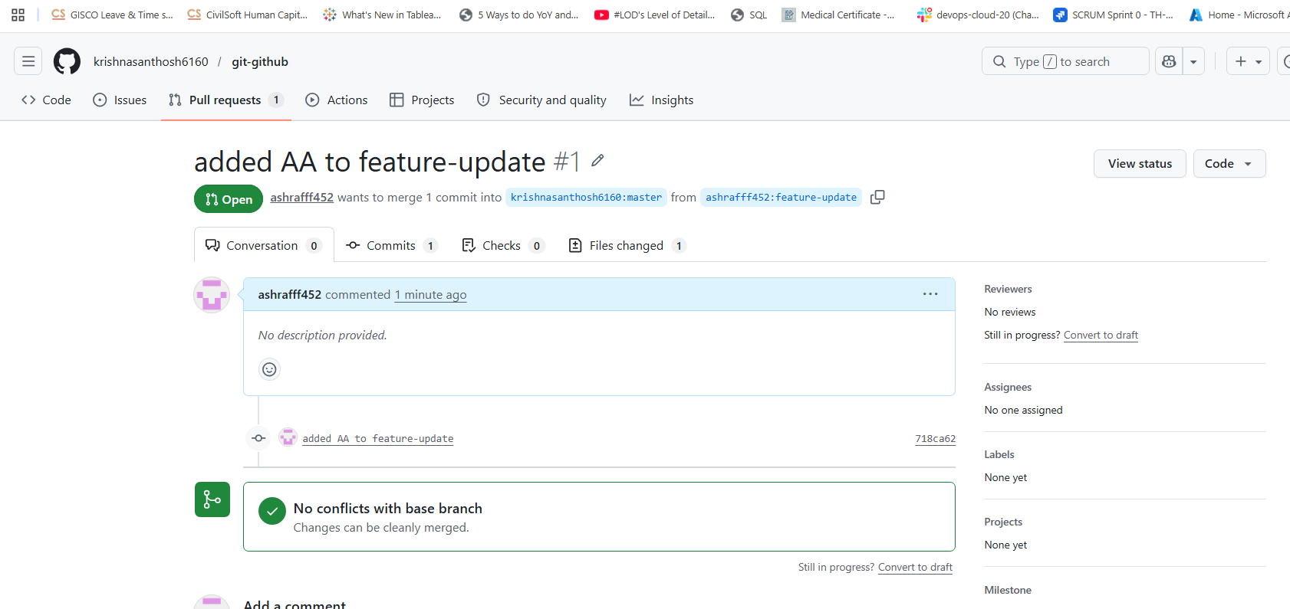

- Recover Lost Commit
  - Commit something, reset hard, and then recover it usinggit reflog.

- Go to Git_2 repo in local machine of Desktop location
- Add contents to already existing file, F1.txt as Version1, Version2 & Version3
- Add and commit for each append
- git log –oneline command to see the commits.
- Reset the last commit by using command, git reset –hard HEAD~1
- To recover we use the command git reflog to see all the commits including the reset ones.
- 9d72958 is the commit Id of the reset ones
- Now git reset –-hard 9d72958 to recover the commit and we can check that by using command git log –oneline & cat F1.txt as well.

